Marketing Research Adjustable Dumbbell

BYZOOM FITNESS Classic Series
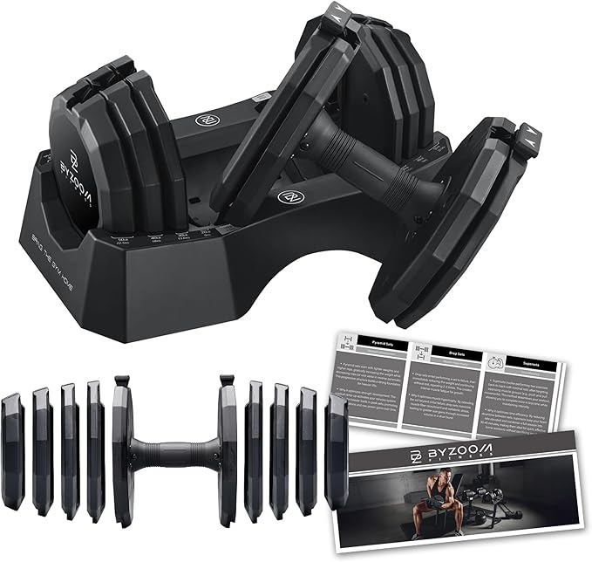

About this item
- ULTIMATE 15-IN-1 PRECISION: The 55LB Classic Series features dual 2.5LB removable micro-plates, giving you 15 precise weight increments to master progressive overload and break through strength plateaus. Buy One Set, Use Longer. Best Value for Home or Garage Gym.
- FORGED CAST IRON DURABILITY: We use high-density, nylon-shielded cast iron to deliver a compact, balanced feel and a solid impact that won’t rattle or crack during high-intensity sessions.
- STABLE 12-SIDED POLYGONAL BASE: Our classic polygonal plates provide a rock-solid, stationary foundation. Use the weights as a stable platform for renegade rows and floor push-ups without the instability or rolling risk of round dumbbells.
- ADJUSTABLE LENGTH: Most adjustables stay bulky even at light weights. Our high-density iron allows the dumbbell to physically shorten from 15.94" to 6.65" as you drop weight, ensuring a natural range of motion that won't bump your body.
- PATENTED DUAL-LOCK SECURITY: Train with the confidence of a 3x World Champion. Our patented safety dovetail mechanism secures the main plates, while the secondary rotation lock keeps micro-plates tight for a silent, rattle-free experience during explosive lifts.
Amazon.com : Adjustable Dumbbell Set

Adjustable Dumbbell Set

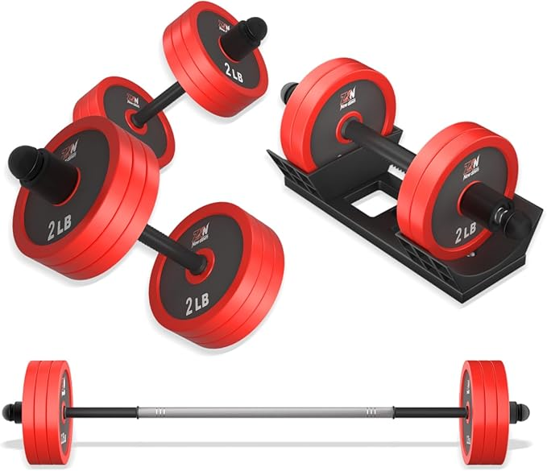

About this item
- This versatile dumbbell set quickly converts into dumbbells, barbells, kettlebells, and push-up stands, making it suitable for a range of exercises, including bench presses, squats, and more. Serves all your exercise and fitness purposes.
- This eco-friendly dumbells pieces exterior is made of cement and iron sand.high-quality PE materials, and the inside is mixed with iron, mud, and sand, which effectively prevents floor abrasion.Deep grooves ensure easy grip.
- This adjustable dumbbell set includes four safety double nuts. The thickened threads on the nuts effectively keep the weight plates secure, double nuts design preventing movement or shaking during workouts. This ensures your safety and provides a stable exercise experience.
- The connecting rod of this weights dumbbells set is made of a 5mm thick steel tube and 20mm thick high-quality foam. Curved design fits the neck, which is non-slip and sweat-absorbing, soft and breathable, bringing a more comfortable exercise experience to you.u.
- The adjustable dumbbells is ergonomic design, the surface of the dumbbell bar is made of ABS environmentally material and attached to a non-slip texture, which strengthens the friction of the hand and helps you control the dumbbell better during exercise.
Amazon.com : BDSHE Adjustable Dumbbell Set, 20lbs Free Weight Set with Upgraded Nut,4 in1 Dumbbells Set Used as Barbell, Kettlebells, Push up Stand, Weight Set for Home Gym Suitable Men/Women : Sports & Outdoors

(03)20LBS Adjustable Dumbbells Set

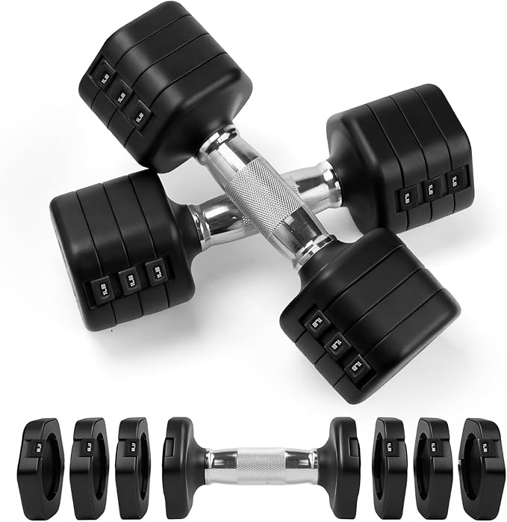

About this item
- This versatile adjustable dumbbell set offers four distinct weights: 4lb, 6lb, 8lb, and 10lb. Its easy adjustability makes these adjustable weights ideal for everyone from beginners to experienced strength trainers.
- Each weight plate features a unique rotating lock combined with an automatic latch, providing double security. You can swiftly add or remove plates from the dumbbell set in seconds.

- The innovative hexagonal shape of these free weights provides multiple flat edges, preventing rolling for safety during use and storage. This stable base also offers versatility for certain floor exercises.
- 【Secure Electroplated Handle】 The handle utilizes special electroplated metal for enhanced stability and long-lasting durability. Its non-slip textured design prevents slipping, even during intense workouts.
Amazon.com : Axiqunel 20LBS Adjustable Dumbbells Set, 4 in 1 Free Weights Dumbbells Set, 4lb 6lb 8lb 10lb with Metal Non Slip Handle, Quick Change Women/Men Dumbbell Set for Home Gym Exercise Training(Black) : Sports & Outdoors

(04)FITPLAM Adjustable dumbbell
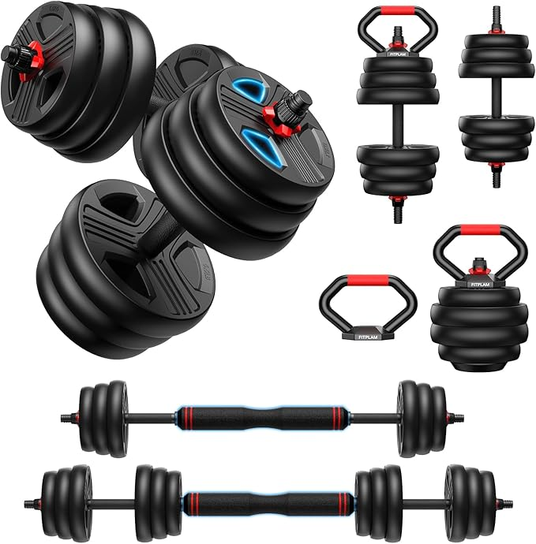

- it, you can get a pair of dumbbells also barbells, kettlebells, and push-up stands, which help you do many exercises including bench presses, squats, etc.
- Environmentally dumbbell pieces exterior is made of high-quality PE materials, and the inside is mixed with iron, mud, and sand, which effectively prevents floor abrasion.
- 1 set. 5 Functions: No more buying dumbbells, kettlebells, barbells, push-up stands, and plates separately. This all-in-one adjustable dumbbell set replaces them all. High value, zero hassle. Easily build your home gym
- Custom Weight for Every Routine: The dumbbell pieces feature a detachable design, and the adjustable weight range for the single dumbbell is 6 lbs-22.5 lbs, the kettlebell is 4 lbs-19.5 lbs, and the barbell is 8 lbs-45 lbs. Suitable for beginners to professionals, it meets your exercise intensity needs in different stages in just one device. Installation is easy
- Solid Iron-Sand Construction: Our plates are integrally molded with high-density iron sand, not loose river sand. Zero shaking, zero rattling, and zero dust leakage—even after years of use. Just solid weight set that lets you focus entirely on your form and explode through every rep with confidence
- 15MM Thickened Foam: Thin padding flattens fast and digs into your neck. Our 15*430 mm high-density foam wraps a 5mm steel core, curved to fit your neck naturally — plush, breathable, sweat-absorbent. Keep the bar off your neck and your mind on the move. An upgrade you’ll feel from rep one to rep one thousand
Amazon.com : 20LBS Adjustable Dumbbell Set, 4 in 1 Free Weights Dumbbells Set for Women Men Hand Weights Sets Adjust Dumbbell Weight Sets for Home Gym Exercise Workout Strength Training Equipments, Black : Sports & Outdoors

(05)FEIERDUN DB3 5-in-1 Adjustable Dumbbell

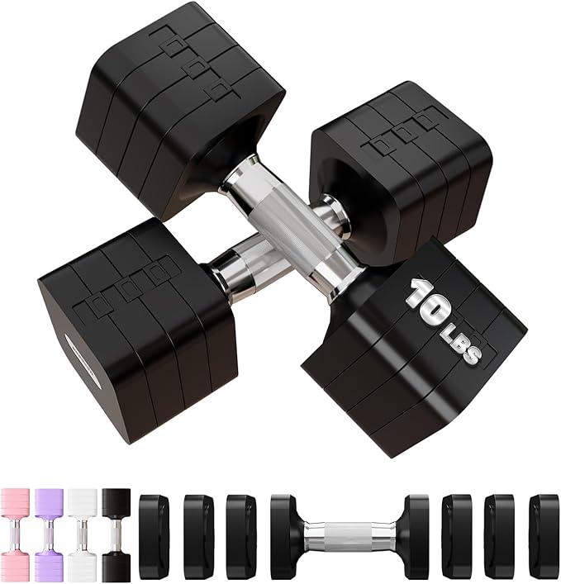

- Adjustable weights for every fitness goal! Customize your routine effortlessly. Whether toning (2-4 lbs), burning fat (4-6 lbs), or building strength (6-10 lbs), this adjustable set adapts to your needs. Easily achieve your fitness goals with just one set of FEIERDUN dumbbells.
- 1S Quick Adjustment for Seamless Workouts: Effortlessly switch from 2LB to 10LB in just one second. Our Adjustable Dumbbells keep your workout flowing, saving time and helping you stay focused on your fitness routine. Ideal for those looking to maximize their workout efficiency without interruptions.
- The 4.5-inch handle is designed to fit most hand sizes and is made from soft TPU material. The raised dot texture enhances grip, allowing you to maintain a firm hold with every movement—even during your sweatiest workouts. No matter how intense your training gets, you’ll stay confident and in control.
- Compact Design for Anywhere Workouts! Our dumbbells occupy just 0.2FT²,our dumbbells fit easily into your gym bag. Whether you're at home, in the office, or on a rehab journey, they effortlessly blend into your daily routine. Stay fit and healthy on the go with this these versatile weights.
- 【No More Rolling】Our square-shaped design ensures stability and prevents slipping. Makes your home gym safer while also making it easy to switch to push-up mode. Enjoy the convenience and enhanced functionality that takes your workout to the next level.

Amazon.com : FEIERDUN Adjustable Dumbbells, 50lbs Free Weight Set with Connector, 4 in1 Dumbbells Set Used as Barbell, Kettlebells, Push up Stand, Fitness Exercises for Home Gym Suitable Men/Women : Sports & Outdoors

(06)Northdeer Steel Dumbbells Ultracompact

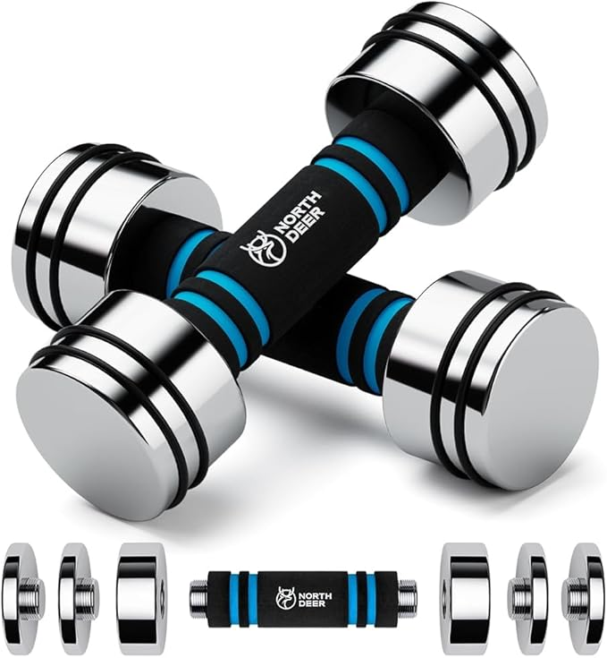
- LITE-VERSION - FOCUS ON PRACTICABILITY: Compared to mirror-finish version, the standard version skip the 1-hour-hand-polishing process in order to reduce the costs. But don’t worry about the quality, because other production processes are exactly the same as with the mirror finishing version dumbbells. Since there are textures made by machines on each weight plate, they can’t reflect things as clearly as with mirror finishing version dumbbells, however, they are still shiny and look great.
- IMPROVE EXERCISE EFFECT: This dumbbell is made of steel, small in size, and easy to grasp. Traditional dumbbells are bulky and limiting in terms of training movements as they often bump into the body during exercise. Using this dumbbell the movements can be more precise, deepening the muscle stimulation and enhancing the training effect.
- SAFE AND FIRM DESIGN: The dumbbell is precisely cut from a single piece of high-quality steel without any welding. Each dumbbell piece is locked to the next, avoiding the problems of traditional dumbbells in which the dumbbell piece shakes due to a loose nut. The handle is made of a foam material which is safe, non-slip, does not hurt your hands, reduces hand pain caused by heavy weight, and allows you to persist in completing the training.

Amazon.com : Hand Weight Set of 2 for Women 5lb Pair (3lb/4lb/5lb) Adjustable Dumbbells with Foam Handles Chrome Home Exercise Gym Workout (Standard-Finish 5lb×2) : Sports & Outdoors

[07]Yes4All Chrome/Rubber Grip Encased
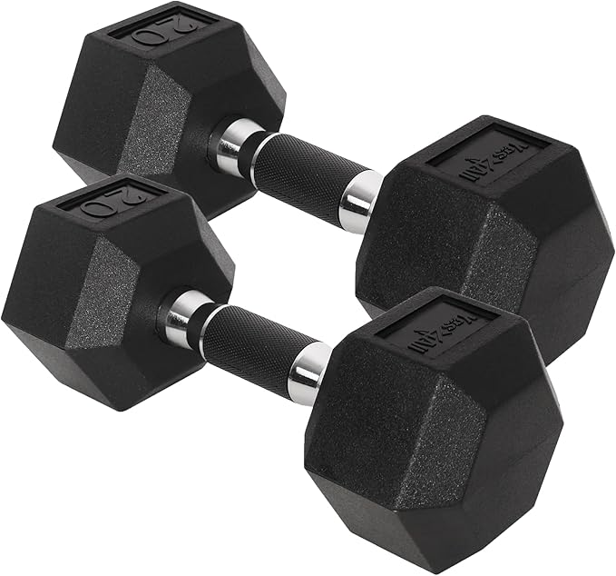

- Our weights dumbbells set for women men that offers different options and does not take up a ton of space. 20 lb is total weight for the pair. Each dumbell has max weight of 10 lbs for a combined total weight of 20 lbs. Please check the SIZE CHART options carefully to see how much weight you want in a single weight.
- 4 In 1 Adjustable Hand weights dumbbells set for men women. Our dumbbell sets consists of 8 weight 0.95lbs dumbbell plate, adjustable range is 4lb, 6lb, 8lb, 10lb each weight (A Pair 8lbs 12lbs 16lbs 20lbs).
- The mechanism to connect and disconnect the additional weighted pieces are simple to use and twist into place, can be quickly to adjust for more or less weight.
- The dumbbell weights set are square and not round. The square shape keeps them from rolling around on the floor or shelf. The handle boasts anti-slip strips to provide better gripping.
- These adjustable dumbbells set is made of tough ABS materials. They are very sturdy and it doesn't like the plastic coating easy chip or break off.

Amazon.com : FEIERDUN 5-in-1 Adjustable Dumbbell Set of 2, 20LBS/10LBS Hand Weights for Women, 1s-Adjust Dual-Stable Dumbbell Set for Women Home Gym & Outdoor : Sports & Outdoors

[08]Adjustable-Dumbbells-Sets
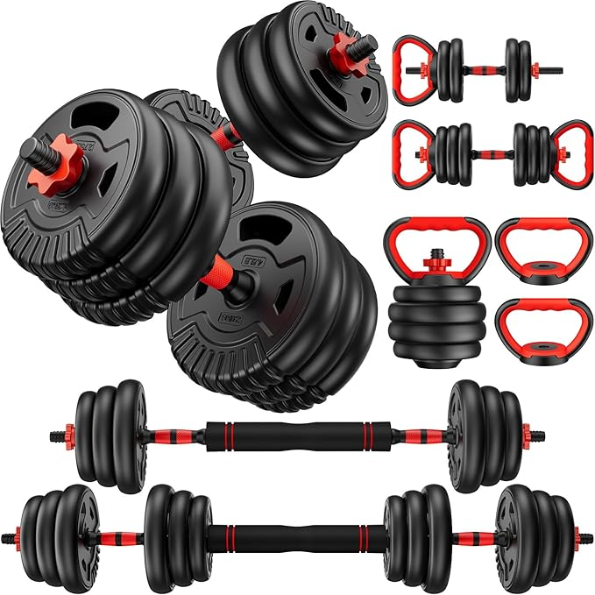

About this item
- EVA
- UPGRADED MATERIAL - Our weight plates are filled with iron sand and wrapped with high-grade PE materials. Prevent damage to the floor and rust. The thickened foam connecting rod conforms to the ergonomic design, reduces the pressure on the shoulder, and avoids sports injuries.
- WEIGHT PACKAGE LIST - 20 lbs fitness dumbbells include: 4 × 2.75lbs weight plates, 4x2.2lbs weight plates,4x dumbbell nuts,1x connertor and 2x dumbbell bar. You can choose different weights according to your own preferences to meet the intensity needs of you and your family at different stages of exercise.
- 3 MODES - BCBIG adjustable dumbbell set, with 3 modes of use: dumbbell, light barbell and heavy barbell. Bring dumbbells to your home，Build your home gym.Get started on your fitness journey with a dumbbell workout!
- THE BEST HOME FITNESS EQUIPMENT - 3-in-1 mode, you can carry out a variety of balance strength training to help exercise biceps brachii, leg and abdominal muscles; It can also help maintain low blood fat and increase oxygen intake to obtain a healthy body.

https://acesse.one/w1sxw4u

